EXP 3
Designing a Quarter wave transformer by varying following parameters a) frequency b) input impedance c) characteristic impedance
Test Case 1:
AIM: To design a quarter-wave transformer for an input impedance (Zin) of 50 ohms and a load impedance (ZL) of 100 ohms and to analyze the transformer's performance as the operating frequency is varied across {100 MHz, 200 MHz, 300 MHz, 500 MHz }.
PROGRAM:
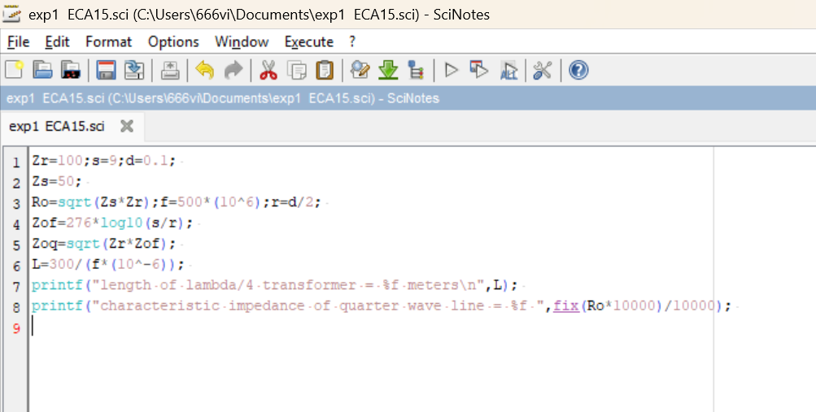

OUTPUT:
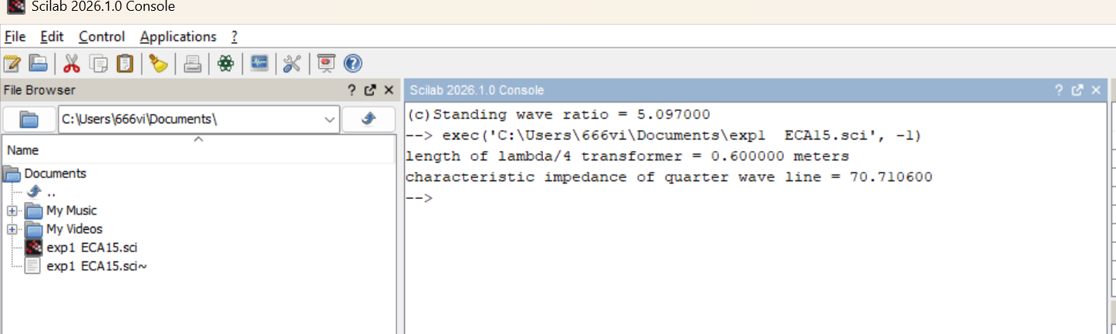

Test Case 2:
AIM: To design a quarter-wave transformer for an input impedance (Zin) of 50 ohms and a load impedance (ZL) of 100 ohms and to analyze the transformer's performance as the operating frequency is varied across {100 MHz, 200 MHz, 300 MHz, 500 MHz }.
PROGRAM:

OUTPUT:

